Lab 3

QT Radio

For this lab, you will construct a GUI that replicates the behavior of an old car radio. The basic layout is illustrated below.

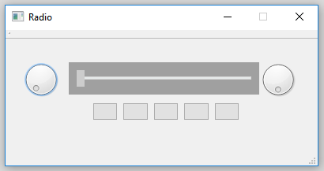

**General requirements**

The knob on the left is the volume knob. It should rotate from about the 7-oclock position (pictured) clockwise through about the 5-oclock position. The volume should range from zero (7-oclock) through 100 (5-oclock). Each time the volume is changed, report the volume through cout. When the volume is zero, the display (the tuner bar) should be “off”. For any other volume, the display should be “on”.

The knob on the right is the tuner knob. Moving the knob clockwise should make the tuner bar move to the right. Moving the tuner knob counter-clockwise should make the tuner bar move to the left. It should require several rotations of the tuner knob to make the tuner bar move the full width of the display. The tuner bar must keep rotating even after the tuner bar has reached its maximum or minimum position.

The tuner bar moves left and right in response to the tuner knob and the preset buttons. It does not respond directly to mouse events. The tuner bar must have two visual representations: one for when the radio is off and one for when it is on.

The five preset buttons respond to both right and left mouse clicks. When a button is right-clicked, it should remember the current tuner position. When a preset button is left-clicked, it should move the tuner to the position set the last time it was right-clicked. If a preset button has never been right-clicked, a left-click should move the tuner bar all the way to the right.

**Other Requirements**

1. The title bar must include your name.
2. The radio must not be resizable (when was the last time you changed the size of the radio in your car?)
3. All of the controls must be placed via a layout (not just hand-placed in the bounding frame).
4. For appearance, you are NOT required to exactly replicate the picture above. The requirements are that the volume and tuning knobs be on the left and right of the tuning bar, and that there be 5 preset buttons under the tuning bar. You can be creative within those guidelines. In your creativity, remember that this is an analog electro-mechanical radio. It is NOT a digi

**Points (out of 100)**

* Proper layout: 20
* Proper behavior: 50
* Good programming practices: 20
* Appearance: 20

Yes, I know that adds up to more than 100. Do something fancy with appearance and you can earn extra credit, but remember, this is an analog electro-mechanical radio, not a digital one.

**Submitting your lab**

Zip up your QT project directory (as a ZIP file, not 7-ZIP, TAR, JAR, PKZIP, otherweirdzip) and submit the ZIP file to blackboard.